

**Project Status Report**



**Project Name:** Barcode Info

**Department:** Operation and Maintenance Department

**Focus Area:** Weather Stations

**Product/Process:** Preventive Maintenance of Weather Stations



**Prepared By:**

|  |  |
| --- | --- |
| **Document Owner(s)** | **Project/Organization Role** |
| Miguel Mayor | Project Manager |
| Joanna De Guzman | Project Editor |
| Adrian Tobias | Project Researcher |

**Project Status Report Version Control**

|  |  |  |  |
| --- | --- | --- | --- |
| **Version** | **Date** | **Author** | **Change Description** |
| 1.0 | 04/13/16 | Miguel Mayor | Document created |
| 1.1 | 04/20/16 | Miguel Mayor | * Statement of the Problem was more specific * Solutions that were in the paper was removed * Paper was modified in a way that it expands what data is used and it focused more on the problem |
| 1.2 | 07/04/16 | Adrian Tobias | * Context, Use Case, and Data flow has been updated * Timing, State, Class, Use Case Fully Development * Paper has be revised to a theoretical view |
| 1.3 | 07/10/16 | Adrian Tobias | * Sequence, Activity, Communication Diagram has been created * Other diagrams are updated according to the noted revisions |
| 1.4 | 07/17/16 | Adrian Tobias | * Change paper according to Computer Science with Software Development format * Project Context added, Purpose and Definition updated, Design and Methodology is added |

**TABLE OF CONTENTS**

1 PROJECT STATUS REPORT PURPOSE 3

2 PROJECT STATUS REPORT TEMPLATE 3

2.1 Project Status Report Details 3

2.2 Project Status Report Template 3

3 PROJECT STATUS REPORT APPROVALS 3

4 APPENDICES 3

4.1 Document Guidelines 3

4.2 Project Status Report Sections Omitted 3

# PROJECT STATUS REPORT PURPOSE

The Project Status Report is a document that Project Managers may use as a means of formal regular reporting on the status of a project to key project stakeholders, including the Steering Committee, Project Sponsor, and Senior Manager.



# PROJECT STATUS REPORT TEMPLATE

## Project Status Report Details

* [Status of the Project]
  + Project Barcode Info plans to design an improved system for the Operations and Maintenance of weather.com.ph by using a more modern algorithm that will provide faster results and convenience compared to the older system.
  + Milestone Deliverable/s: The parts of the paper updated according to the format
  + Due to the numerous comments and corrections of the project advisor, the project is slightly delayed. Though there has been a delay, these changes could lead to further improvement of the system.

* [Budget Report]
  + Food and Beverages – ₱ 450
  + Transportation - ₱ 200

* [Risk Management Report—Specify any changes to the major risks identified since the previous report and modification to the strategies put in place to manage them, if appropriate.]
  + Diagrams are completed but other parts of the main paper are to be added

* [Issues Report]
  + Updated the paper but needs to be checked by project advisor so that revisions could be made
* (Recommendations) Gain more information from the client so that the design of the web application is according to the clients design

## Project Status Report Template

|  |  |  |
| --- | --- | --- |
| Barcode Info | | |
| Prepared By:  Adrian Tobias | Date:  07/04/16 | Reporting Period:  07/08/16 to 07/09/16 |
| Project Overall Status:   * New Diagrams are improved | | |
| Project Summary:   * Currently making tweaks and changes to the diagrams needed | | |
| **Milestone Deliverables performance reporting over last period**   |  |  |  |  | | --- | --- | --- | --- | | **Milestone Deliverables** | **Due Date** | **% Completed** | **Deliverable Status** | | Milestone 1 | | | | | * The rest of the diagrams | 07/14/16 | 100% | On Schedule | | * Status Report | 07/14/16 | 100% | On Schedule | | * Improvement of the parts of the paper | 07/14/16 | 70% | On Schedule | | Milestone 2 | | | | |  |  |  | On Schedule | |  |  |  | On Schedule | |  |  |  |  | | | |
| **Milestone Deliverables scheduled for completion over next period**   |  |  |  |  | | --- | --- | --- | --- | | **Milestone Deliverables** | **Due Date** | **% Completed** | **Deliverable Status** | | Milestone 1 | | | | | * The other parts of the paper | 07/24/16 | 0% | On Schedule | |  |  |  | On Schedule | |  |  |  |  | | Milestone 2 | | | | |  |  | 0% | On Schedule | |  |  | 0% | On Schedule | | | |
| **Project impact of milestone success or failure for project remainder**   |  |  | | --- | --- | | Project will have a main paper where it could define the proposed system | There are still missing parts in the paper | | | |
| **Project** **Budget/Financial Status**   |  |  |  |  | | --- | --- | --- | --- | | **Budget Item** | **Planned Budget** | **Actual Cost** | **Variance/Explanation** | | Food and Beverages | 600 | 389 | Food and Beverages consumed | | | |
| **Project Risk Management Status**   |  |  |  |  |  | | --- | --- | --- | --- | --- | | **Risk and Description** | **Risk Chance** | **Risk Impact** | **Risk Priority** | **Change from Last Review** | | Will the new system improved the old system? | Medium | High | High | Diagrams are completed for the support of the paper | | | |
| **Project Issue Management Status**   |  |  |  |  |  | | --- | --- | --- | --- | --- | | **Issue and Description** | **Project Impact** | **Target Due Date** | **Issue Status** | **Issue Resolution** | | Paper: missing parts | High | 07/24/16 | Open | Paper needs to be updated with the missing parts filled up | | | |
| **Project Recommendations**   |  | | --- | | * Will the project deliverables be completed within acceptable quality levels?   The deliverables will be submitted before their deadlines. The new requirements will be checked and verified by our Advisor   * Are project issues and risks being addressed successfully and mitigated?   Yes, they be addressed and we will make solutions to solve the problems and issues presented in this status report | |  | | | |
| **Objectives for Next Project Status Review**   |  | | --- | | * To have our paper checked and reviewed * To add the missing parts | | | |
| **Related Project Information**   |  | | --- | |  | | | |



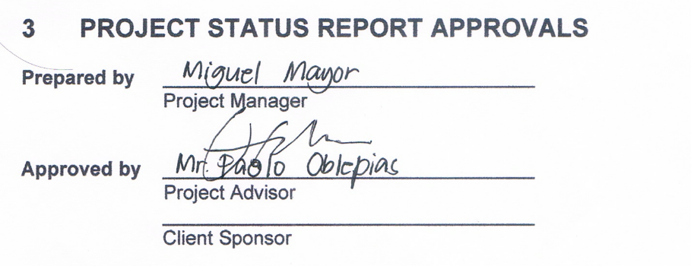



# APPENDICES

## Document Guidelines

## Project Status Report Sections Omitted

